SAMPLE TEST

PRZYKŁADOWY TEST

LISTENING COMPREHENSION

This is the listening section of the test. There are three parts to this section.

PART I

Directions: You will see a picture in your test book and you will hear four short statements.

Look at the picture in your test book and choose the statement that best describes what you see in the picture. Then mark your answer on your answer sheet.

Look at the sample below and listen to the four statements.

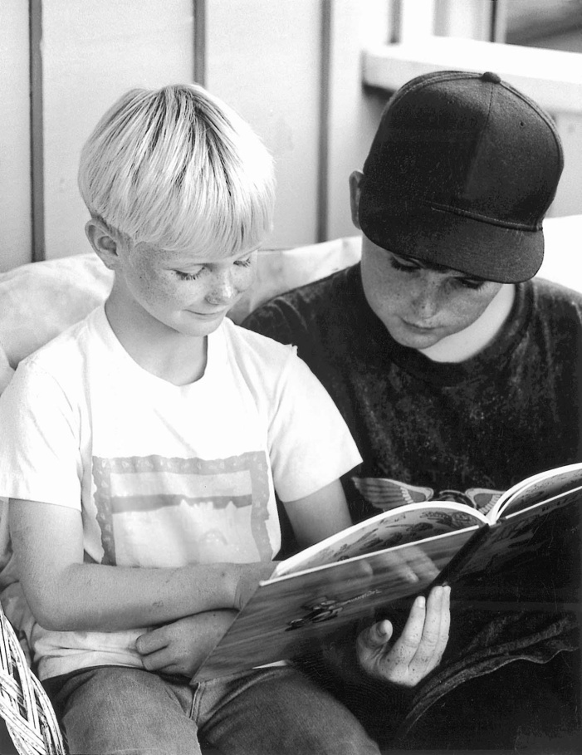

Statement (B), “The boys are reading,” best describes what you see in the picture. Therefore, you should choose answer (B).

Now let us begin Part I with question number one.

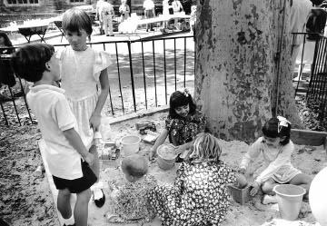
illustration / Rysunek 2.

illustration / Rysunek 1.

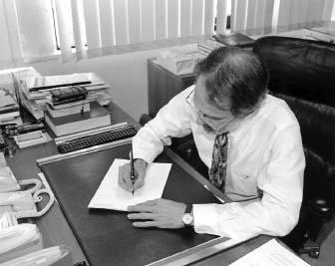
illustration / Rysunek 3.

PART II

Directions: Now, you will hear a question or statement followed by three responses. Choose the best response to each question or statement.

Now listen to a sample question.

You will hear: | Good morning, John. How are you?
You will also hear: | (A) | I am fine, thank you.
 | (B) | I am in the living room.
 | (C) | My name is John.

Sample Answer

A B C

The best response to the question “How are you?” is choice (A), “I am fine, thank you.” Therefore, you should choose answer (A).

Now let us begin Part II with question number 16.

- Mark your answer on your answer sheet.

- Mark your answer on your answer sheet.

- Mark your answer on your answer sheet.

- Mark your answer on your answer sheet.

PART III

Directions: Now, you will hear several short talks or conversations.

In your test book, you will read a question followed by four answers. Choose the best answer to each question and mark it on your answer sheet.

Now let us begin Part III with question number 36.

- Where is the man going?

  - To a clothing store.

  - To a barbershop.
  - To the bank.
  - To the dry cleaner’s.

- Who is this announcement for?

  - Pilots.

  - Taxi drivers.
  - Passengers.
  - Travel agents.

- What are the people waiting for?

  - Their photographs.

  - Their mail.
  - Their friends.
  - Their car.

- What is the weather like now?

  - Windy.

  - Humid.
  - Cold.
  - Rainy.

This is the end of the Listening Comprehension portion of the test. Turn to Part IV of the test.

YOU WILL HAVE THIRTY-FIVE MINUTES TO COMPLETE PARTS IV AND V OF THE TEST.

READING

This is the reading section of the test. There are two parts to this section.

PART IV

Directions: This part of the test has incomplete sentences. There are four words or phrases, marked (A), (B), (C), and (D), under each sentence. Choose the one word or phrase that best completes the sentence. Then mark your answer on your answer sheet.

Example
Please turn off your computer at the ------- of the day.
 | Sample Answer
(A) ends | A B C D
- ending
- end
- ended

The sentence should read, “Please turn off your computer at the end of the day.” Therefore, you should choose answer (C).

Now begin work on the questions.

51. Thank you very much for ------- us here. |  | 54. Alice Shapiro is a close friend of -------.
(A) | invite | (A) | my
(B) | invited | (B) | myself
(C) | have invited | (C) | me
(D) | inviting | (D) | mine
52. After thirty minutes, ------- remove the dish from |  | 55. ------- I prefer coffee, I usually drink tea at work.
the oven. |  | (A) | Even
(A) | carefully | (B) | Although
(B) | careful | (C) | But
(C) | more careful | (D) | Despite
(D) | most careful | 56. Many people ------- that Diana Franklin wins the
53. The community talent show was canceled
 |  | election tomorrow.
because we sold very few -------. |  | (A) | like
(A) | tickets | (B) | want
(B) | bills | (C) | hope
(C) | labels | (D) | expect
(D) | notes

PART V

Directions: The questions in this part of the test are based on reading materials such as notices, letters, forms, and advertisements. Choose the one best answer, (A), (B), (C), or (D), to each question. Then mark your answer on your answer sheet.

Read the following example.

NOTICE

CAFETERIA CLOSED

Will reopen Monday, June 5

What will happen on June 5?

- The workers will take a day off.

- The cafeteria will open.
- The prices will go down.
- The school will close.

Sample Answer

A B C D

The notice says that the cafeteria is closed and will open again on June 5. Therefore, you should choose answer (B).

Now begin work on the questions.

Questions 81–82 refer to the following announcement.

Book Fair

Many great books to choose from!

When: May 3 and 4, 10 A.M. to 5 P.M.

Where: School cafeteria

Why: All money from the sale
will be used to support the
school orchestra

81. What is the announcement about? |  | 82. When does the sale end?
(A) | Eating lunch | (A) | At 3:00 P.M.
(B) | Listening to an orchestra | (B) | At 4:00 P.M.
(C) | Going to school | (C) | At 5:00 P.M.
(D) | Buying books | (D) | At 10:00 P.M.

Questions 83 –85 refer to the following e-mail message.

From: Mark Hampton

To: David Smith

Cc:

Sent: Thursday, 7:00 P.M.

Subject: Tomorrow night

Hi David,

My father has given me two tickets to the baseball game tomorrow night. Do you want to come? It starts at 8:00 p.m. If you can make it, give me a call here at home tonight or early tomorrow. If I don’t hear from you by tomorrow morning, I’ll assume you can’t make it.

Mark

83. Where is Mark now? |  | 85. When must David reply?
(A) | At a café | (A) | By this evening
(B) | At a friend’s house | (B) | By tomorrow morning
(C) At his home |  | (C) | By tomorrow afternoon
(D) At a baseball stadium |  | (D) | By tomorrow night

- What does Mark want David to do?

  - Go with him to a game

  - Eat dinner with him
  - Visit him at home
  - Leave a message with his father

Stop! This is the end of the test. If you finish before time is called, you may go back to Parts IV and V and check your work.

Correct Answers – Poprawne Odpowiedzi

Part I | Part II | Part III | Part IV | Part V
1. D | 16. C | 36. D | 51. D | 82. C
2. A | 17. B | 37. C | 52. A | 83. C
3. B | 18. B | 38. A | 53. A | 84. A
 | 19. A | 39. C | 54. D | 85. B
 |  |  | 55. B
 |  |  | 56. C

